Exp. No: 9
ANALYSIS OF PHOTODETECTOR NOISE AND SNR USING MATLAB
OBJECTIVES
1. Analyze the key noise sources in an optical photodetector, namely shot noise, dark current noise and thermal (receiver) noise.
2. Compute the individual and total noise current variances (σ²) across a range of input optical powers.
3. Evaluate the Signal-to-Noise Ratio (SNR) and observe its scaling in the thermalnoise-limited and shot-noise-limited regimes.
4. Calculate the Minimum Detectable Optical Power (Pmin) at SNR = 1 (0 dB).
5. Simulate and visualize photodetector noise and SNR curves using MATLAB.

SOFTWARE REQUIRED
• MATLAB software

MATLAB CODE

% Photodetector Noise and SNR Analysis
clc;
clear;
close all;
%% 1. Constants and input parameters
q = 1.602e-19; % Electron charge (C)
kB = 1.381e-23; % Boltzmann constant (J/K)
h = 6.626e-34; % Planck's constant (J.s)
c = 2.998e8; % Speed of light (m/s)
lambda = 1550e-9; % Wavelength (m)
eta = 0.85; % Quantum efficiency
Id = 5e-9; % Dark current (A)
T = 300; % Temperature (K)
RL = 50; % Load resistance (ohm)
Fn = 2; % Noise figure (linear)
B = 1e9; % Bandwidth (Hz)
Pdbm = -60:0.1:0; % Input power (dBm)
P = 10.^((Pdbm - 30)/10); % Input power (W)
%% 2. Responsivity and signal current
R = eta*q*lambda/(h*c); % Responsivity (A/W)
Ip = R.*P; % Photocurrent (A)
%% 3. Noise variances and SNR
var_shot = 2*q.*Ip*B; % Shot noise variance (A^2)
var_dark = 2*q*Id*B; % Dark current noise variance
var_th = 4*kB*T*B*Fn/RL; % Thermal noise variance
var_tot = var_shot + var_dark + var_th;
SNR = Ip.^2 ./ var_tot;
SNR_dB = 10*log10(SNR);
%% 4. Minimum detectable power (SNR = 1)
% R^2*P^2 - 2*q*B*R*P - (var_dark + var_th) = 0
a = R^2;
b = -2*q*B*R;
cc = -(var_dark + var_th);
Pmin = (-b + sqrt(b^2 - 4*a*cc))/(2*a);
PmindBm = 10*log10(Pmin) + 30;
%% 5. Display calculated results
[~,k] = min(abs(Pdbm - (-30)));
fprintf('Responsivity R = %.4f A/W\n', R);
fprintf('Thermal variance = %.3e A^2\n', var_th);
fprintf('Dark variance = %.3e A^2\n', var_dark);
fprintf('Shot variance (-30 dBm) = %.3e A^2\n', var_shot(k));
fprintf('SNR at -30 dBm = %.2f dB\n', SNR_dB(k));
fprintf('Pmin (SNR = 1) = %.2f dBm (%.1f nW)\n',PmindBm, Pmin*1e9);
%% 6. Test cases: -50 dBm, -30 dBm and 0 dBm
Ptest_dBm = [-50, -30, 0];
fprintf('\n----- TEST CASE RESULTS -----\n');
for i = 1:length(Ptest_dBm)
Pin_dBm = Ptest_dBm(i);
Pin = 10^((Pin_dBm - 30)/10);
Iptest = R*Pin;
shot_test = 2*q*Iptest*B;
total_test = shot_test + var_dark + var_th;
SNR_test = Iptest^2/total_test;
SNR_test_dB = 10*log10(SNR_test);
fprintf('\nInput power = %.0f dBm\n', Pin_dBm);
fprintf('Photocurrent = %.3e A\n', Iptest);
fprintf('Shot variance = %.3e A^2\n', shot_test);
fprintf('Thermal variance = %.3e A^2\n', var_th);
fprintf('Total variance = %.3e A^2\n', total_test);
fprintf('SNR = %.2f dB\n', SNR_test_dB);
end
%% 7. Plots
figure;
subplot(2,1,1);
loglog(P, var_th*ones(size(P)), ...
P, var_dark*ones(size(P)), ...
P, var_shot, ...
P, var_tot, 'LineWidth', 1.2);
grid on;
xlabel('Input Power (W)');
ylabel('Noise Variance (A^2)');
title('Photodetector Noise Variance');
legend('Thermal Noise', 'Dark Noise', ...
'Shot Noise', 'Total Noise', 'Location', 'best');
subplot(2,1,2);
plot(Pdbm, SNR_dB, 'b', 'LineWidth', 1.5);
hold on;
plot([-60 0], [0 0], 'r--', 'LineWidth', 1.2);
plot([PmindBm PmindBm], [-60 70], 'k:', 'LineWidth', 1.2);
grid on;
xlabel('Input Power (dBm)');
ylabel('SNR (dB)');
title('Signal-to-Noise Ratio versus Input Power');
legend('SNR', 'SNR = 0 dB', ...
'Minimum Detectable Power', 'Location', 'best');
hold off;
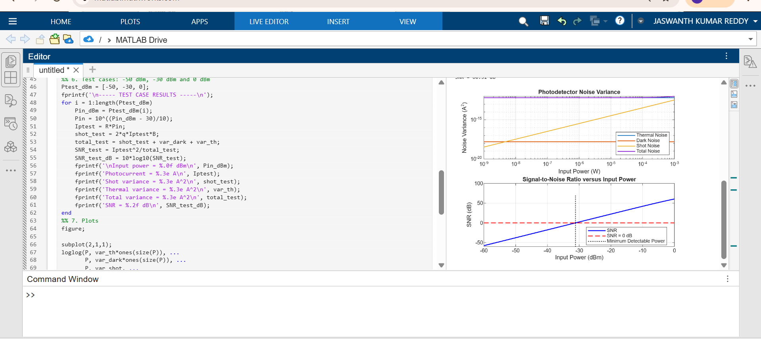
OUTPUT GRAPH

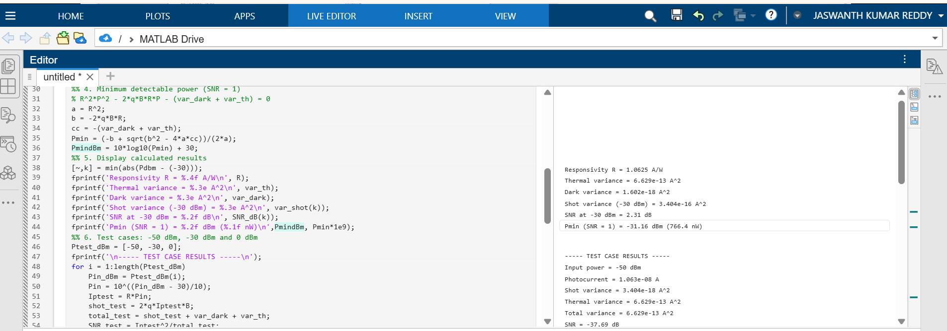

Reflection
I learned how thermal noise, dark current and shot noise affect receiver performance and how SNR changes with input optical power.

LABORATORY PERFORMANCE ASSESSMENT RUBRIC
Objective | Assessment Criterion | Excellent – 4 | Good – 3 | Satisfactory – 2 | Needs Improve-ment – 1 | Weight-age
Develop the MATLAB  program with correct constants and system parameters. | Program Setup and Parameter Definition | Defines all constants and parameters correctly with proper units and a clean script structure, independently. | Defines parameters correctly with minor unit or syntax errors and limited assistance. | Defines most parameters but needs considerable assistance or has unit errors (e.g., dBm/W, linear Fn). | Unable to set up the script or define the parameters. | 25
Compute R, signal current, noise variances and SNR across the power sweep. | Simulation Execution and Data Acquisition | Computes R, Ip, all noise variances and SNR correctly over −60 to 0 dBm and records the values. | Computes all quantities with minor errors or omissions. | Computes some quantities with noticeable errors or inconsistencies. | Unable to run the simulation or record the values. | 25
Obtain the noise and SNR plots and determine Pmin. | Graph Plotting and Pmin Determination | Plots accurate log–log and semi-log curves with labels and reference lines; Pmin within 5% of the reference. | Plots the curves with minor errors; Pmin identified with small deviation. | Plots partial or poorly scaled curves; Pmin approximate. | Unable to plot the curves or determine Pmin. | 25
Interpret noise regimes, SNR slopes and receiver sensitivity. | Analysis and Engineering Interpretation | Correctly identifies thermal- and shot-limited regimes, explains the SNR slopes and links results to receiver design. | Identifies the regimes with minor errors and reasonable interpretation. | Performs basic interpretation with noticeable errors or limited justification. | Unable to interpret the results. | 25

Result
Photodetector noise and signal-to-noise ratio were analyzed using MATLAB.

